AI Assisted Coding
ASSIGNMENT - 4

Name: Arun
HT No: 2303A52064
Batch: 32
Question 1:
Zero-Shot Prompting (Basic Lab Task)
Task 1:
Write a Java function that classifies a given text as Spam or Not Spam using zero-shot prompting.
Steps:
1. Construct a prompt without any examples.
2. Clearly specify the output labels.
3. Display only the predicted label.
Input: "Congratulations! You have won a free lottery ticket." Expected Output: Spam
Prompt:
Code:
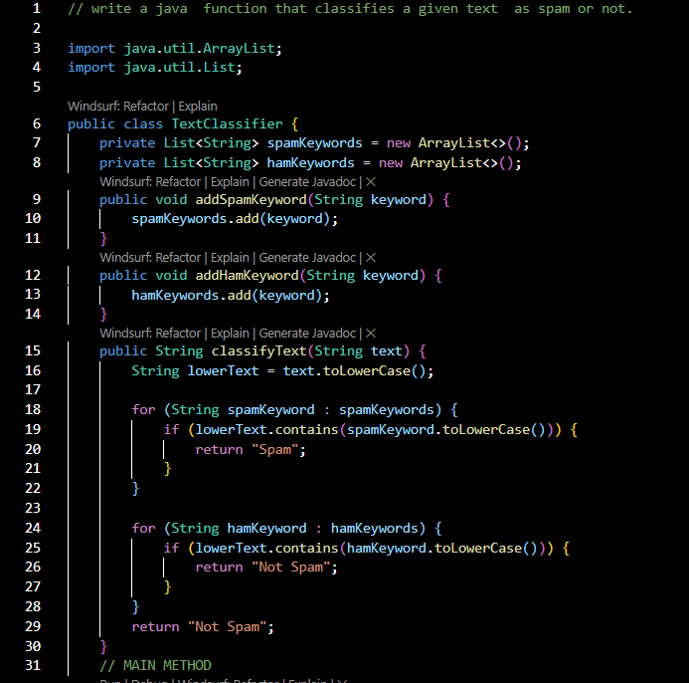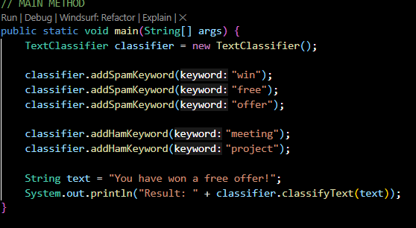
Output:
If any keyword is found, it classifies the text as "Spam"; otherwise, it classifies it as "Not Spam".

Question 2:
One-Shot Prompting (Emotion detection)
Task 2:
Write a Java program that detects the emotion of a sentence using one-shot prompting.
Emotions: [‘happy', 'sad', 'angry', 'excited', 'nervous', ’neutral’] Steps:
1. Provide one labeled example inside the prompt.
2. Take a sentence as input.
3. Print the predicted emotion
Prompt:
Code:
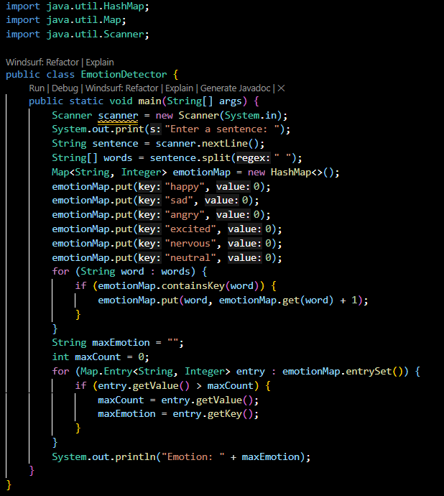
Output:
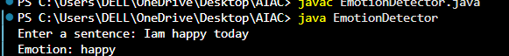

Question 3:
Few-Shot Prompting (Student Grading Based on Marks)
Task 3:
Write a Java program that predicts a student’s grade based on marks using few-shot prompting.
Grades: ['A', 'B', 'C', 'D', 'F']
Grading Criteria (to be inferred from examples):
• 90–100 → A
• 80–89 → B
• 70–79 → C
• 60–69 → D
• Below 60 → F
Prompt:
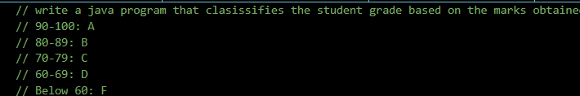
Code:
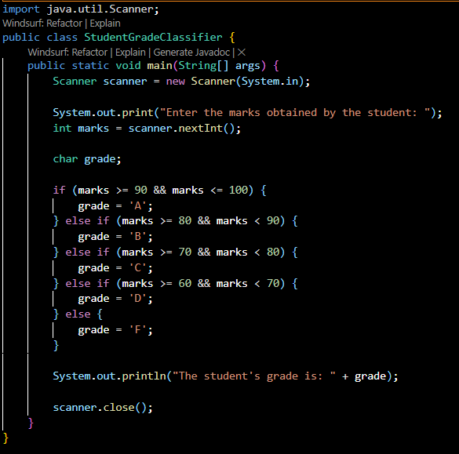
Output:
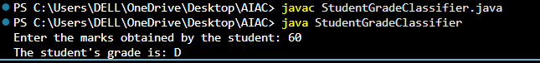
Question 4:
Multi-Shot Prompting (Indian Zodiac Sign Prediction using Month Name)
Task 4:
Write a Java program that predicts a person’s Indian Zodiac sign (Rashi) based on the month of birth (month name) using multi-shot prompting.
Indian Zodiac Order (Simplified Month-Based Model):
The Indian Zodiac cycle starts in March with Mesha and follows this order:
March → Mesha
April → Vrishabha
May → Mithuna
June → Karka
July → Simha
August → Kanya
September → Tula
October → Vrischika
November → Dhanu
December → Makara
January → Kumbha
February → Meena
Prompt:
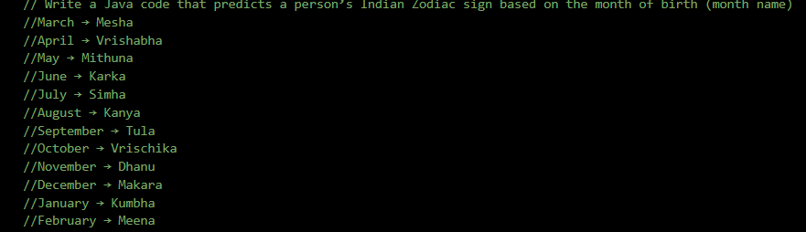
Code:
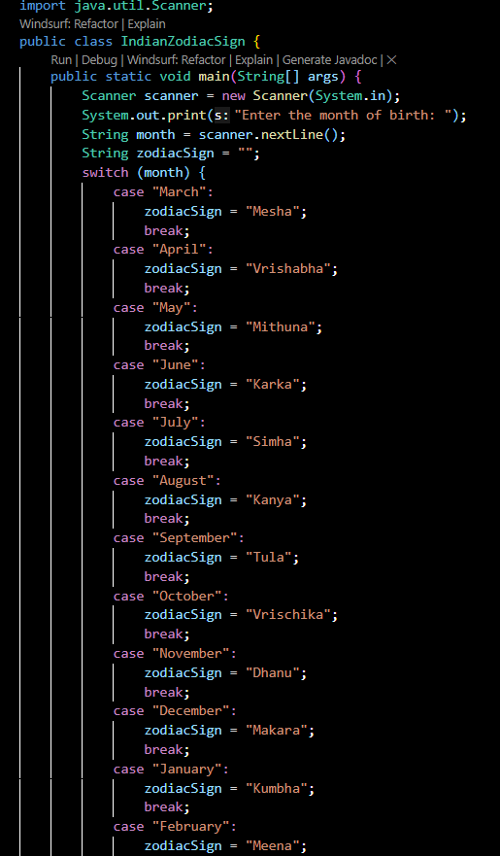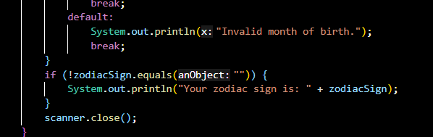
Output:
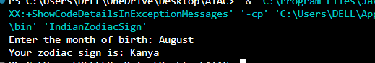
Question 6:
Voting Eligibility Check (Chain-of-Thought Prompting)
Task 6:
Write a Java program that determines whether a person is
eligible to vote using Chain-of-Thought (CoT) prompting.
Prompt:
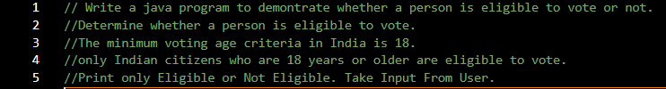
Code:
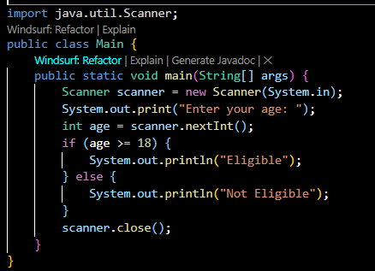
Output:
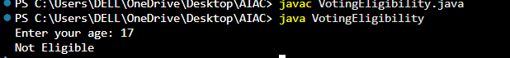
Question 5:
Result Analysis Based on Marks
Task 5:
Write a Java program that determines whether a student Passes or Fails based on marks using Chain-of-Thought (CoT) prompting.
Result Categories: ['Pass', 'Fail']
Prompt:
Code:
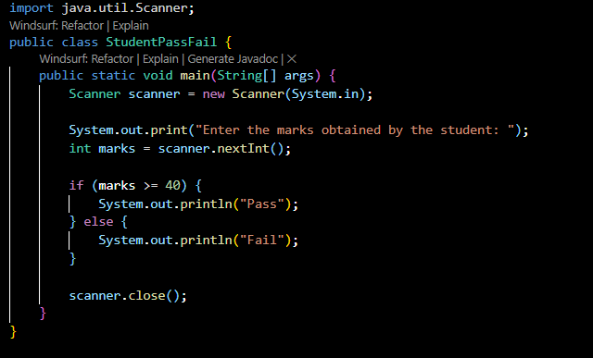
Output :
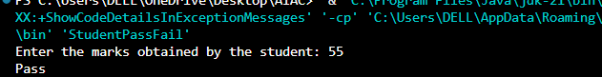
Question 7:
Prompt Chaining (String Processing – Palindrome Names)
Task 7:
Write a Java program that uses the prompt chaining technique to identify palindrome names from a list of student names.
Prompt:
Code :
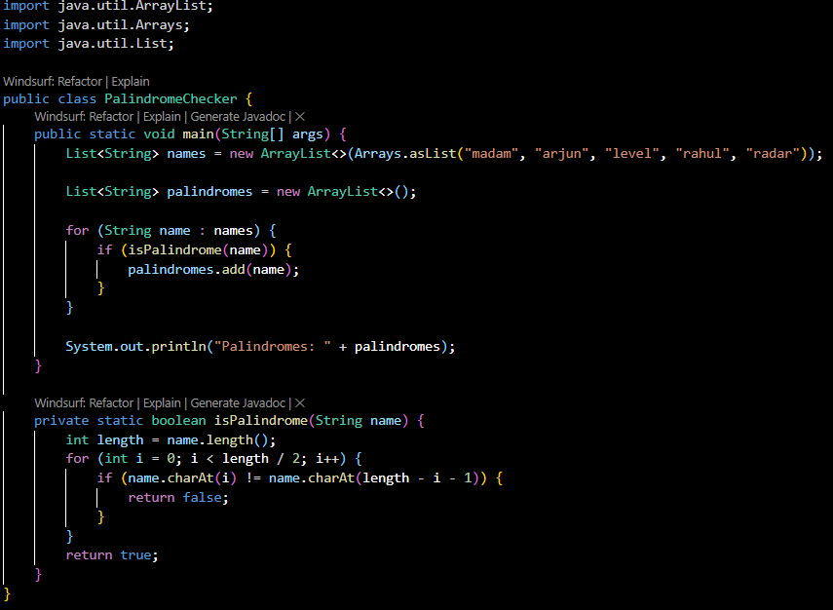
Output:
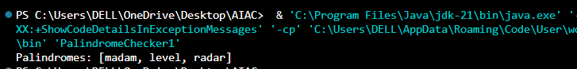
Question 8:
Prompt Chaining (String Processing – Word Length Analysis)
Task 8:
Write a Java program that uses prompt chaining to analyse a list of words. In the first prompt, generate a list of words. In the second prompt, traverse the list and calculate the length of each word. In the third prompt, use the output of the previous step to determine whether each word is Short (length less than 5) or Long (length greater than or equal to 5), and display the result for each word
Prompt:
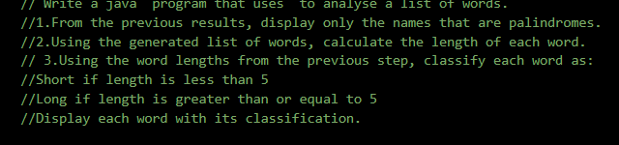
Code:
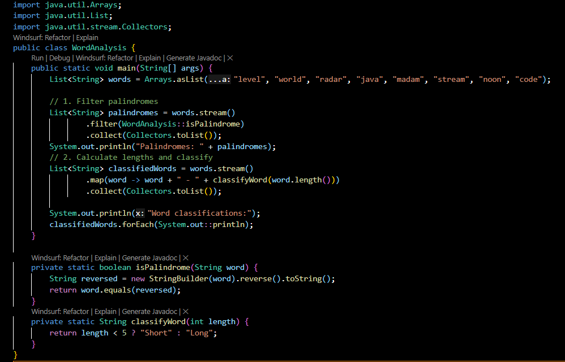
Output:
